HCI Assignment

Andreas Patricio Valentino

2540118126

Colour Used

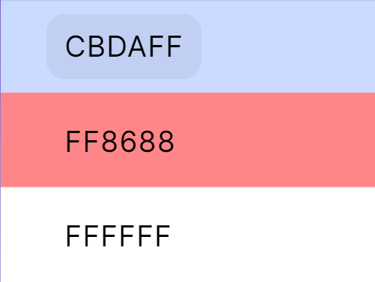

Design Reference List

1. <http://www.malmetropolitan.com/index.php>
2. <http://mallbassura.id>
3. <https://www.pacificplace.co.id>

Assets from free image website <https://unsplash.com>